Consider a 5 by 5 table containing a key word or phrase. To start, pick a word that does not contain any letter more than once, then fill the remaining spaces with the rest of the letters of the alphabet in order or one would first fill in the spaces of the table with the letters of the keyword (dropping any duplicate letters). For example, pick the word KEYWORD. Now write the letters of that word in the first squares of a five by five matrix. Then finish filling up the remaining squares of the matrix with the remaining letters of the alphabet, in alphabetical order. Since there are 26 letters and only 25 squares, we assign I and J to the same square.

K | E | Y | W | O
R | D | A | B | C
F | G | H | I/J | L
M | N | P | Q | S
T | U | V | X | Z

To encrypt a message, one would break the message into digraphs (groups of 2 letters) such that, for example, "HelloWorld" becomes "HE LL OW OR LD", and map them out on the key table. If needed, append a "Z" to complete the final digraph. The two letters of the digraph are considered as the opposite corners of a rectangle in the key table. Note the relative position of the corners of this rectangle. Then apply the following 4 rules, in order, to each pair of letters in the plaintext:
- If both letters are the same (or only one letter is left), add an "X" after the first letter. Encrypt the new pair and continue.
- If the letters appear on the same row of your table, replace them with the letters to their immediate right respectively (wrapping around to the left side of the row if a letter in the original pair was on the right side of the row).
- If the letters appear on the same column of your table, replace them with the letters immediately below respectively (wrapping around to the top side of the column if a letter in the original pair was on the bottom side of the column).
- If the letters are not on the same row or column, replace them with the letters on the same row respectively but at the other pair of corners of the rectangle defined by the original pair. The order is important – the first letter of the encrypted pair is the one that lies on the same row as the first letter of the plaintext pair.
Ex.
Using "playfair example" as the key, the table becomes:
P L A Y F
I R E X M
B C D G H
K N O Q S
T U V W Z
Encrypting the message "Hide the gold in the tree stump":
HI DE TH EG OL DI NT HE TR EX ES TU MP
1. The pair HI forms a rectangle, replace it with BM | 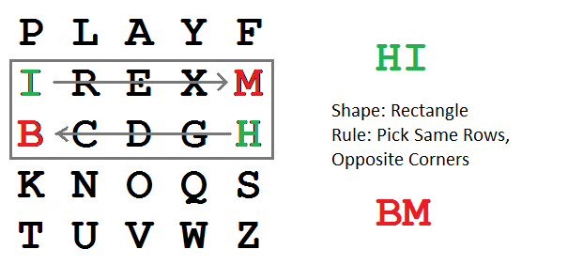
2. The pair DE is in a column, replace it with OD | 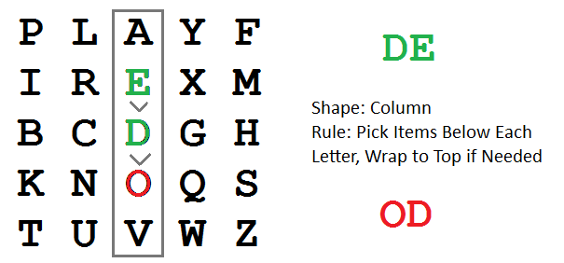
3. The pair TH forms a rectangle, replace it with ZB | 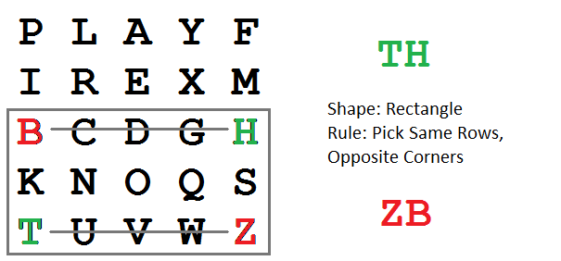
4. The pair EG forms a rectangle, replace it with XD | 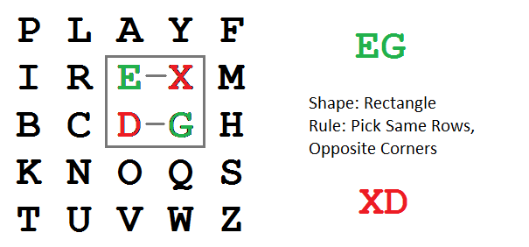
5. The pair OL forms a rectangle, replace it with NA | 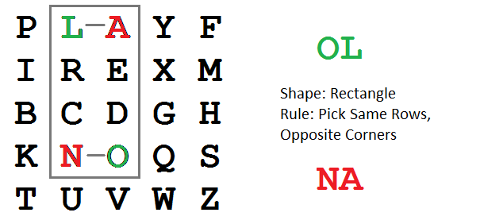
6. The pair DI forms a rectangle, replace it with BE
7. The pair NT forms a rectangle, replace it with KU
8. The pair HE forms a rectangle, replace it with DM
9. The pair TR forms a rectangle, replace it with UI
10. The pair EX (X inserted to split EE) is in a row, replace it with XM | 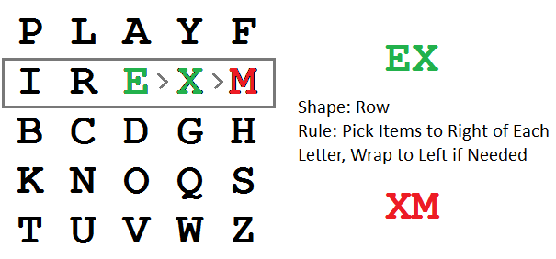
11. The pair ES forms a rectangle, replace it with MO
12. The pair TU is in a row, replace it with UV
13. The pair MP forms a rectangle, replace it with IF
BM OD ZB XD NA BE KU DM UI XM MO UV IF
Thus the message "Hide the gold in the tree stump" becomes "BMODZBXDNABEKUDMUIXMMOUVIF".

